The Water Cycle  Water on earth is used over and over. The water  cycle, the continuous movement of water from ocean to air and land then back to the ocean in a cyclic pattern, is a central concept in meteorology. In the water cycle, the sun heats the Earth's surface water, causing that surface water to evaporate (gas). This water vapor then rises into the earth's atmosphere where it cools and condenses into liquid droplets. These droplets combine and grow until they become too heavy and fall to the  earth as precipitation (liquid if rain, solid if snow).  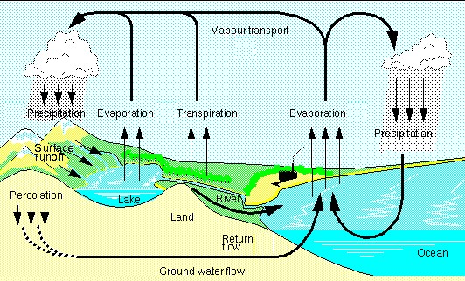  Water is temporarily stored in lakes, glaciers, underground, or living organisms. The water can move from these places by streams and rivers, returns to the oceans, is used by plants or animals or is evaporated directly back into the atmosphere.  Important Terms: • evaporation  - transpiration  - condensation  - precipitation  - infiltration (percolation)  - surface runoff  - groundwater  - absorption  - sublimation | Engage: Where does the water we drink come from?  Questions to ask yourself:  - Is there such a thing as ‘new’ water?  - What does dinosaur pee have to do with my bottle of drinking water?  - What are the processes involved in the global water cycle?  - Where do you get the water you use in your house from?  - Where is most of the water on Earth located?  Before doing the two activity sheets:  All life on Earth requires some form of water to survive. What are some organisms that need a lot of water to survive? How about humans? What percentage of our bodies is made up of water?  The distribution and exchange of water on Earth is represented using the global water cycle. The water cycle describes the existence and movement of water on, in, and above the Earth. Earth's water is always in movement and is always changing states, from liquid to vapour to ice and back again.  The water cycle has been working for billions of years and all life on Earth depends on it continuing to work. This means that the water we are using today could have been used by a dinosaur or ancient civilizations.  Is there such a thing as new water? No, the amount of water on Earth is and has been constant since its formation millions of years ago.

The Global Water Cycle
- Rivers and streams  - Glaciers  - Runoff  - Groundwater | - Condensation  - Transpiration  - Sublimation  - Evaporation | - Oceans  - Atmosphere  - Precipitation  - Infiltration (percolation)
Water is stored in 5 places on Earth. Name each place and note the phase that water is in (i.e., liquid, solid, or gas).

Place | Phase?
1)
2)
3)
4)
5)

There are 7 processes involved in the water cycle. Name and define each process. Include the phase change that water goes through during each process.

Process | Definition | Water phase? | Place?
1)
2)
3)
4)
5)
6)
7)

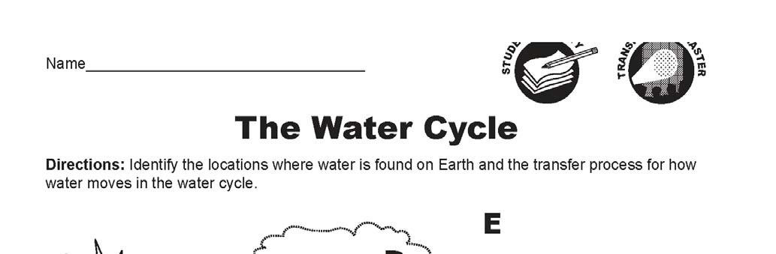
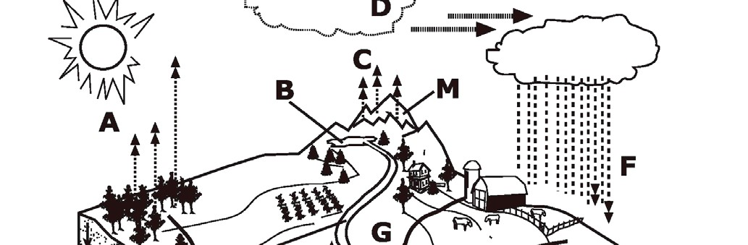
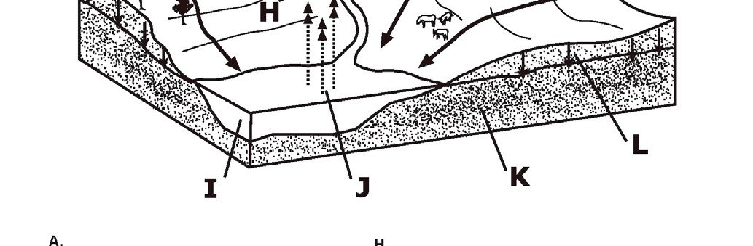
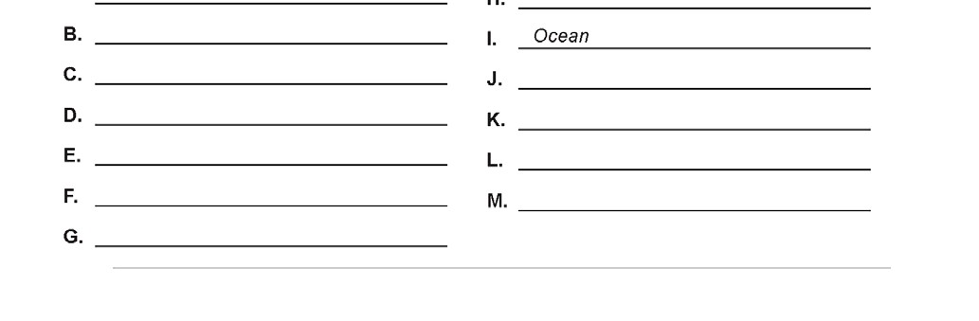

The Global Water Cycle [ANSWER KEY]

- Lakes and Streams  - Glaciers  - Runoff  - Groundwater | - Condensation  - Transpiration  - Sublimation  - Evaporation | - Oceans  - Atmosphere  - Precipitation  - Infiltration (percolation)
Water is stored in 5 places on Earth. Name each place and note the phase that water is in (i.e., liquid, solid, or gas).
Place | Phase?
1) Lakes and Streams | Liquid (water)
2) Glaciers | Solid (ice)
3) Groundwater | Liquid (water)
4) Oceans | Liquid (water)
5) Atmosphere | Gas (vapor)

There are 7 processes involved in the water cycle. Name and define each process. Include the phase change that water goes through during each process.

Process | Definition | Water phase? | Place?
1) Runoff | Precipitation runs over land into a water body | Liquid → Liquid | Any area adjacent to a water body
2) Condensation | Water vapor turns into liquid water | Gas → Liquid | Atmosphere
3) Transpiration | Loss of water vapor from plants | Liquid → Gas | Plant surfaces, atmosphere
4) Sublimation | The conversion of snow or ice directly into water vapor | Solid → Gas | Glaciers and Icecaps
5) Evaporation | The conversion of liquid water into water vapor | Liquid → Gas | Surface of water bodies
6) Precipitation | The condensation of water vapor into liquid water droplets | Gas → Liquid | Atmosphere
7) Infiltration | Water that is absorbed into the Earth | Liquid → Liquid | Land
2

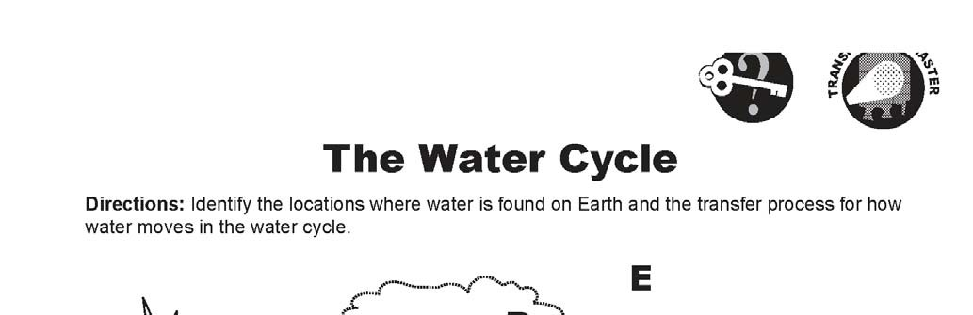
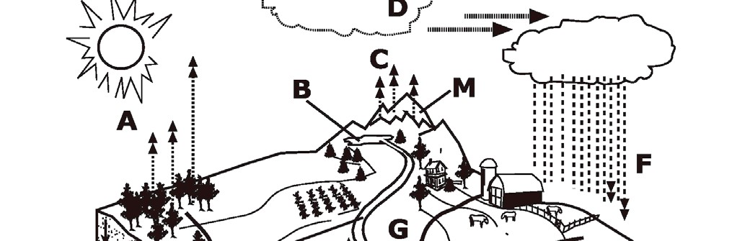
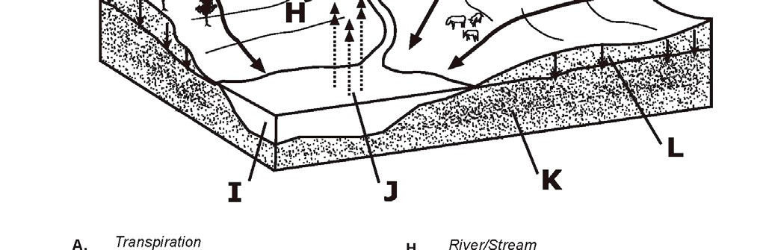
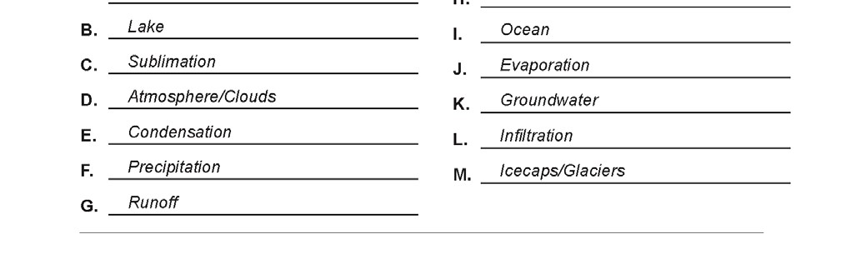
2

